Teacher Notes for "Genetic Engineering Challenge
– How can scientists develop a type of rice that could prevent vitamin A deficiency?"

This analysis and discussion activity begins with an introduction to vitamin A deficiency and a review of transcription, translation, and the universal genetic code. Several questions challenge students to design a basic plan that could produce a genetically engineered rice plant that makes rice grains that contain pro-vitamin A. Subsequent information and questions guide students as they learn how scientists use bacteria to insert desired genes, together with an appropriate promoter, in the DNA of plant cells. In a final optional section, students evaluate the pro and con arguments in the controversy concerning Golden Rice.

Before students begin this activity, they should have a basic understanding of DNA, proteins, and transcription and translation. To provide this background, you may want to use:
- the hands-on activity "From Gene to Protein – Transcription and Translation" (https://serendipstudio.org/sci_edu/waldron/#trans) or
- the analysis and discussion activity “From Gene to Protein Via Transcription and Translation” (https://serendipstudio.org/exchange/bioactivities/trans).

Learning Goals
In accord with the Next Generation Science Standards:
- Students prepare for the Performance Expectation HS-LS3-1. "Ask questions to clarify relationships about the role of DNA and chromosomes encoding the instructions for characteristic traits passed from parents to offspring."
- Students learn the following Disciplinary Core Ideas:
- LS1.A – Structure and Function. "Genes are regions in the DNA that contain the instructions that code for the formation of proteins."
- LS3.A – Inheritance of Traits. “Each chromosome consists of a single very long DNA molecule, and each gene on the chromosome is a particular segment of that DNA. The instructions for forming species’ characteristics are carried in DNA. All cells in an organism have the same genetic content but the genes used (expressed) by the cell may be regulated in different ways. Not all DNA codes for a protein; some segments of DNA are involved in regulatory or structural functions, and some have no as-yet known function.”
- Students engage in recommended Scientific Practices, including:
- “Constructing Explanations and Designing Solutions. Apply scientific ideas, principles, and/or evidence to provide an explanation of phenomena and solve design problems…”
- This activity provides the opportunity to discuss the Crosscutting Concept:
- "Cause and Effect: Mechanism and Prediction. Cause and effect relationships can be suggested and predicted for complex natural and human designed systems by examining what is known about smaller scale mechanisms within the system."

Additional Learning Goals
- Promote student understanding of molecular biology concepts, including:
- Genes code for proteins (including enzymes).
- The genetic code is universal.
- Transcription of genes is the first step in producing proteins.
- Almost all the cells in an organism have the same genes in their DNA, but different types of cells have different rates of transcription of specific genes. This is one reason why different types of cells have different amounts of specific proteins. These proteins contribute to the specialized functions of different types of cells.
- Promoters at the beginning of each gene play a crucial role in regulating the rate of transcription of each gene in different types of cells.
- Develop an understanding of the basic steps of one type of genetic engineering.
- Evaluate the advantages and disadvantages of one type of genetically modified food.

Suggestions for Discussion and Background Information
If your students are learning online, we recommend that they use the Google Doc version of the Student Handout, which is available at https://serendipstudio.org/exchange/bioactivities/GeneEdit. To answer questions 4a, 7 and 8a, students can either print the relevant pages, draw on them and send you pictures, or they will need to know how to modify a drawing online. They can double-click on the relevant drawing in the Google Doc, which will open a drawing window. Then, they can use the editing tools to add text. You may want to revise the GoogleDoc or Word document to prepare a version of the Student Handout that will be more suitable for your students; if you do this, please check the format by viewing the PDF.

To maximize student participation and learning, I suggest that you have your students work individually or in pairs to complete groups of related questions and then have a class discussion after each group of related questions. In each discussion, you can probe student thinking and help them develop a sound understanding of the concepts and information covered before moving on to the next group of related questions.

A key for this activity is available upon request to Ingrid Waldron, iwaldron@upenn.edu. Some additional background information and suggestions for discussion are provided below.

Pro-vitamin A, also called beta-carotene, is found in many plant foods (e.g. deep orange and dark green vegetables such as carrots, sweet potatoes and spinach). As shown in the diagram below, beta-carotene can be enzymatically split to form retinal (a form of vitamin A that can be converted to the other forms of vitamin A used in the body). Vitamin A is found in some animal foods (especially liver). Excess vitamin A in the diet can be toxic. Pro-vitamin A may be a safer dietary source of vitamin A since increased intake of beta-carotene results in decreased conversion of beta-carotene to vitamin A.

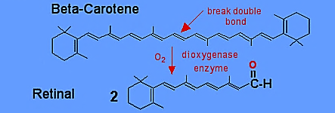

Vitamin A deficiency is common in children in poor countries, resulting in an estimated 250,000-500,000 cases of blindness each year and about half that number of deaths due to increased susceptibility to infectious diseases (https://www.who.int/data/nutrition/nlis/info/vitamin-a-deficiency).

White rice has been milled and polished to remove the hull, bran and germ, leaving only the endosperm which contains thousands of cells, abundant starch and some protein. In the figure on page 1 of the Student Handout, the endosperm is labeled as "white rice". The major advantage of white rice is the removal of most of the oils, which tend to become rancid when stored, especially at warm temperatures. Brown rice has the hull removed, but keeps the germ and bran. The major advantage of brown rice is higher levels of B vitamins and vitamin E. Neither white rice nor brown rice provides pro-vitamin A or vitamin A.

Researchers have not found any type of rice plant that has pro-vitamin A in the rice grains, so scientists cannot use conventional breeding techniques to develop a type of rice plant that has pro-vitamin A in the rice grains. This is the reason why scientists turned to genetic engineering.

Question 3 will serve to remind the students that genes code for proteins, including enzymes that synthesize other needed molecules such as pro-vitamin A.

With respect to question 4b, genetic engineering to add a gene or genes is only useful because the genetic code is universal. A universal genetic code means that the relationship between the sequence of nucleotides in the DNA of a gene and the sequence of amino acids in the protein is the same for all organisms. Therefore, any type of organism can transcribe and translate a gene from any other type of organism.

Question 5 is designed to get students thinking about the problems that scientists confront when developing a genetically engineered plant. Question 5a may be challenging for students if they do not have any background information about genetic engineering; it is hoped that having students discuss this question in pairs will stimulate them to come up with some possible strategy, even if it is only injecting DNA in the rice cells' nuclei.

The bacterium discussed in the section "Inserting the Desired Genes in the DNA of Rice Plants" is Agrobacterium tumefaciens. This bacterium can inject a crucial part of the DNA in its plasmid into plant cells to form recombinant DNA in the plant cell nucleus, as shown in the first figure on page 3 of the Student Handout. You may want to mention the following points to clarify this figure.
- As in many diagrams, the relative dimensions are distorted; e.g., the bacterium appears much larger than it actually is relative to the plant cell and the plasmid appears much larger than it is relative to the bacterium.
- The plasmid is called the Ti or tumor-inducing plasmid because the infected plant cells multiply and produce a bulging growth.
- The vir genes in the plasmid code for the vir proteins that carry out the transfer of the T-DNA from the bacteria into the plant cell DNA.

If you want to introduce the term, “recombinant DNA”, you can insert the following after question 7 in the Student Handout.

8a. Recombinant DNA contains genes from two different organisms. Use an asterisk (*) to indicate the location of the recombinant DNA in the above figure.

8b. This recombinant DNA contains DNA from the _________________ and the ________________.

The bacterial part of the recombinant DNA contains genes that code for enzymes to make opines (modified amino acids that are synthesized by the plant cells and leak out where they are consumed by the bacteria as food) and genes that code for the production of plant hormones that stimulate plant cell division and the production of Crown galls (as shown below; the plasmid is called T_{i} or tumor-inducing because it induces the formation of Crown galls). These Crown galls provide abundant food for the bacteria to grow and multiply. To make use of the genetic engineering capabilities of this bacterium, scientists need to insert the genes for the enzymes to make pro-vitamin A into the T-DNA of the T_{i} plasmid and remove the Crown gall-inducing bacterial genes from the T-DNA of the T_{i} plasmid.

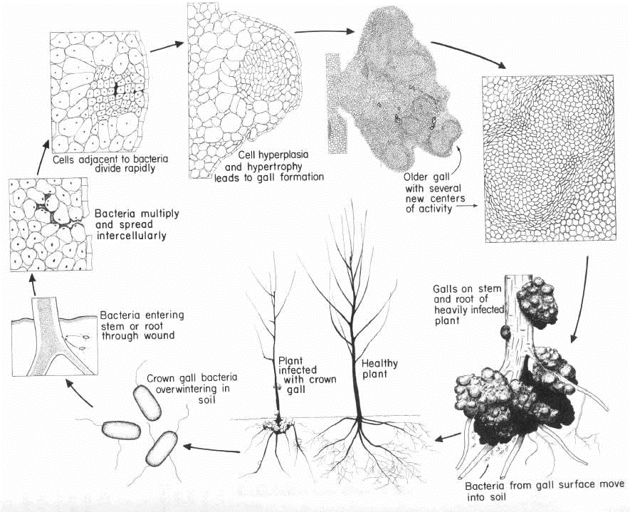
http://www.btny.purdue.edu/Extension/Pathology/PHM/BD/picts/agrobacteriumlc.jpg

Useful sources of additional information are:
- "Gene manipulation in plants" (http://www.open.edu/openlearn/science-maths-technology/science/biology/gene-manipulation-plants/content-section-2.1)
- "The Microbial World: Biology and Control of Crown Gall" (http://archive.bio.ed.ac.uk/jdeacon/microbes/crown.htm).

This is just one example of how scientists frequently make use of the specialized capabilities of bacterial molecular systems to carry out genetic engineering. Another example is the use of bacterial CRISPR-Cas systems for gene editing (“Gene Editing with CRISPR – A Cure for Severe Sickle Cell Anemia?” at https://serendipstudio.org/exchange/bioactivities/GeneEdit).

In the section, “Ensuring that the Genes for the Enzymes to Make Pro-Vitamin A are Active in Rice Grain Cells”, students are introduced to the regulation of transcription of specific genes in different types of cells. This is an important biological concept, which provides the basis for understanding one aspect of genetic engineering.

A promoter is a DNA sequence where RNA polymerase can bind and begin transcription of a gene (see figure below). Some promoters are inducible, which means that they can be turned on or off in different types of cells. At the beginning of each gene in the plasmid used to make Golden Rice, scientists inserted an inducible promoter that is turned on in rice grain cells. The specific promoter used was a promoter for a storage protein gene that is transcribed in rice grain cells. This promoter ensures that the genes for the enzymes to make pro-vitamin A are transcribed in the rice grain cells.
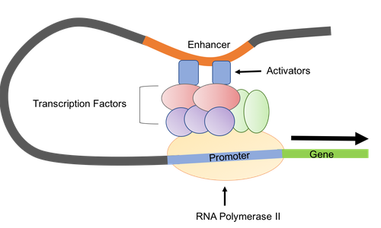
(https://www.addgene.org/mol-bio-reference/promoters/)

As illustrated in the figure above, the regulation of gene expression in eukaryotic cells involves much more than just a promoter. However, it is the promoter that needs to be incorporated at the beginning of the coding region of the gene as it is prepared for use in genetic engineering. A helpful explanation of the regulation of transcription is available at https://www.nature.com/scitable/topicpage/gene-expression-14121669/.

Multiple additional steps are needed for the type of genetic engineering discussed in this activity, including:
- the use of restriction enzymes to make recombinant plasmids;
- the use of transgenic bacteria to clone the gene of interest;
- the need for a marker that will allow scientists to select for plant cells that have been transformed;
- the need to cross the transgenic rice plants with local breeds that have desirable characteristics such as adaptation to local weather conditions and resistance to a variety of plant pests and diseases;
- the need to test the safety of the food and test for possible adverse environmental effects of the plants.

The development of Golden Rice illustrates the iterative nature of scientific research (http://www.open.edu/openlearn/science-maths-technology/science/biology/gene-manipulation-plants/content-section-4.3). The effectiveness of the genetic engineering techniques was improved and the amount of pro-vitamin A in the rice grains was increased by repeatedly trying different approaches and using the results of these experiments, together with new ideas, to develop new approaches to be tested. This iterative process has included:
- trying different techniques to transform rice plant cells,
- research on the biosynthetic pathway for producing beta-carotene (pro-vitamin A) which has shown that only two enzymes need to be genetically engineered into the rice plant cells,
- research to find specific versions of the genes for these enzymes that result in production of higher levels of beta-carotene.

For additional information about the science of genetically modified food plants, see:
- “Genetically Modified Foods” (https://learn.genetics.utah.edu/content/science/gmfoods/)
- “Genetic Engineering in Food Agriculture” (Module 2 in https://www.fda.gov/media/140264/download).

The final section on the Golden Rice controversy recommends sources that are relatively moderate and factual, as opposed to the many extreme opinion pieces on both sides of the controversy. You can shorten this section by using only the first recommended source, which provides a useful overview; this overview favors the development and use of Golden Rice by presenting and rebutting the main arguments of the opposition. The second recommended source has multiple important specific points for both sides of the controversy; this will help students understand the complexity of the factors that should be considered in making decisions about Golden Rice. The third and fourth recommended sources describe recent developments in the Philippines.

Students should be encouraged to keep an open mind and consider the specific arguments for and against the introduction of genetically engineered Golden Rice. You may also want to point out that most Americans consume a fair amount of food from genetically engineered plants, including oil from genetically engineered soybean plants, corn syrup and other products from genetically engineered corn plants, and sugar from genetically engineered sugar beets (https://www.ers.usda.gov/data-products/adoption-of-genetically-engineered-crops-in-the-us/recent-trends-in-ge-adoption.aspx; https://civileats.com/2012/10/18/americans-eat-their-weight-in-genetically-engineered-food/).

Additional useful sources concerning the Golden Rice controversy include:
- “GMO Golden Rice Offers No Nutritional Benefits Says FDA” (https://www.independentsciencenews.org/news/gmo-golden-rice-offers-no-nutritional-benefits-says-fda/)
- “Is Golden Rice the Only Way to Provide Vitamin A to People in Developing Countries?” (http://ucbiotech.org/answer.php?question=38)

Follow-up Activity
Gene Editing with CRISPR – A Cure for Severe Sickle Cell Anemia? https://serendipstudio.org/exchange/bioactivities/GeneEdit
This analysis and discussion activity introduces Victoria Gray whose severe sickle cell anemia was effectively treated by experimental gene editing with CRISPR. To begin, students review the molecular biology of sickle cell anemia. Next, they learn how bacteria use CRISPR-Cas to defend against viral infections. Then, students review the multiple research findings that scientists used to identify the target for gene editing, and they analyze the CRISPR gene editing treatment for sickle cell anemia. Finally, students consider ethical controversies related to the use of CRISPR.

Sources for Figures in Student Handout
- Transcription and translation on page 2 – adapted from https://images.saymedia-content.com/.image/t_share/MTc0MTY5ODg1MDM0MDk2MTI0/protein-production-a-step-by-step-illustrated-guide.jpg
- Bacterium inserting T DNA in plant cell on page 3 – adapted from http://www.open.edu/openlearn/science-maths-technology/science/biology/gene-manipulation-plants/content-section-2.2
- Steps to produce genetically engineered rice plants – from http://classes.midlandstech.edu/carterp/Courses/bio225/chap09/09-18_TiPlasmid_1.jpg

By Dr. Ingrid Waldron, Department of Biology, University of Pennsylvania, 2021. These Teacher Notes and the related Student Handout are available at https://serendipstudio.org/exchange/bioactivities/geneticengineer.
Next Generation Science Standards, available at http://www.nextgenscience.org/next-generation-science-standards
To draw a shape - At the top of the page, find and click Shape. - Choose the shape you want to use. - Click and drag on the canvas to draw your shape. To insert text, click Insert at the top of the drawing. Click Text Box and drag it to where you want it. Type your text. When you are done, click Save and Close.

